**Demonstrate how to set up Postman:**

To start using the API Builder, you can create a new API in your workspace. You can also upgrade, rename, or delete existing APIs.

**Creating an API:**

Select APIs in the sidebar and select +.

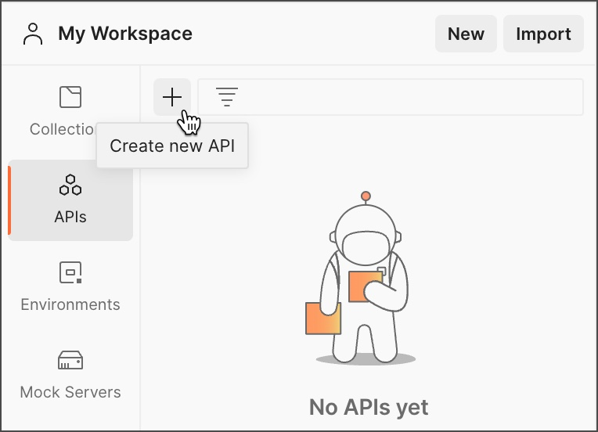

Enter a name for your new API.

Select an option for creating your API:

Connect to a Git repository and import your API definitions and collections into Postman. Learn more about [API version control](https://learning.postman.com/docs/designing-and-developing-your-api/versioning-an-api/versioning-an-api-overview/).

Continue without a repository.

To start working with your new API:

[Create a new API definition](https://learning.postman.com/docs/designing-and-developing-your-api/developing-an-api/defining-an-api/#adding-an-example-api-definition) for your API.

[Use a collection as a starting point for your API](https://learning.postman.com/docs/designing-and-developing-your-api/developing-an-api/adding-api-elements/). Select a collection in your workspace you want to use and add a copy of it to your API. You can also create new collections in your API.

[Import an existing API definition](https://learning.postman.com/docs/designing-and-developing-your-api/importing-an-api/) from a file, a folder, a code repository, or an API gateway.

Postman supports OpenAPI (versions 1.0, 2.0, 3.0, and 3.1), RAML (0.8 and 1.0), protobuf (protocol buffer) (2.0 and 3.0), GraphQL, or WSDL (1.0 and 2.0) definitions. OpenAPI definitions can be JSON or YAML. RAML definitions must be YAML. Protobuf definitions are .proto files. GraphQL definitions can be JSON or GraphQL SDL. WSDL definitions must be XML.

Upgrading an API

Postman recommends upgrading your APIs to the latest format. The Postman v9 API format has been deprecated. If you have v9 APIs, you can upgrade them to the v10 format. After upgrading, you can continue working with your APIs in Postman. In the future, all APIs that are still in v9 format will be automatically upgraded to v10.

The Postman API v9 endpoints have also been deprecated. Any workflows that use the v9 endpoints will no longer work with an API that's been upgraded to the v10 format. Instead, use the [new Postman API v10 endpoints](https://learning.postman.com/docs/developer/postman-api/intro-api/#about-v9-and-v10-apis) for your workflows.

Postman v10 can display APIs created in prior versions of Postman. To work with the API in Postman v10, you need to upgrade the API to the new v10 format. You'll be prompted to upgrade the API when you make changes to it, for example, adding a collection, adding a definition, or connecting to a Git repository. Select Upgrade this API to complete the upgrade.

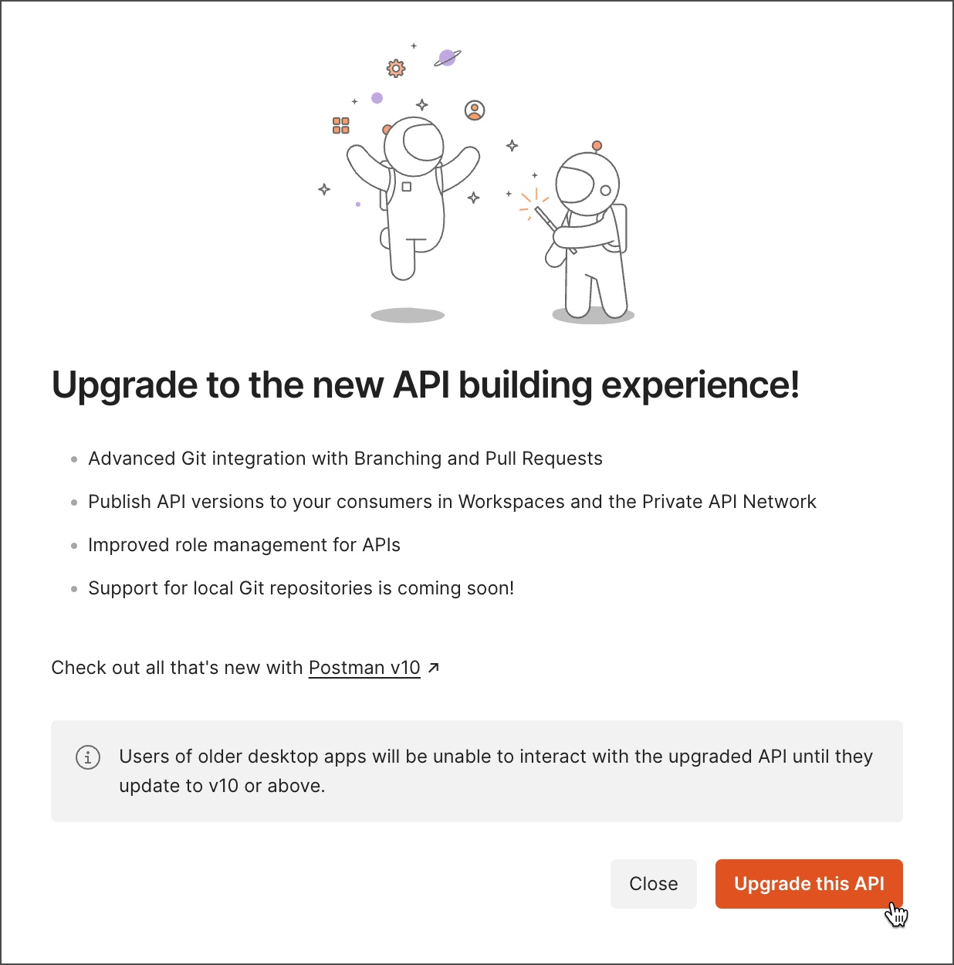

There are some differences in the way API versions work in Postman v10 compared to v9:

In Postman v9, versions were major iterations of your API you could work on at the same time. In Postman v10, [published versions](https://learning.postman.com/docs/designing-and-developing-your-api/versioning-an-api/api-versions/)